**English Test Primary Year 4 T3 March 2019**

**Name:_____________________________________________________**

1. **Look at the timetable and answer the questions.**

|  |  |  |  |  |  |
| --- | --- | --- | --- | --- | --- |
| **Time** | **Monday** | **Tuesday** | **Wednesday** | **Thursday** | **Friday** |
| **9:30** | English | History | Maths | Maths | English |
| **11:00** | Science | Geography | Sport | Music | Maths |
| **12:30** | L u n c h | | | | |
| **1:30** | Science | Maths | Maths | English | Art |
| **3:00** | Maths | English | English | Science | Art |

What have you got on Thursday at 12:30?

_____________________________________________________________

What time have you got English on Friday?

_____________________________________________________________

What have you got on Tuesday?

_____________________________________________________________

On what day is sport?

_____________________________________________________________

What days have you got maths?

_____________________________________________________________

1. **Put he words in the correct order.**

Peter /my /brother /is /my /sister /is /and /Mary

___________________________________________________________________

Christmas / in /we / celebrate / December

___________________________________________________________________

Have / we / English /Mondays / got / on / Tuesdays / and / Fridays

___________________________________________________________________

Mother /a / kitchen /in /the /cake /is/my /making

___________________________________________________________________

In / March / birthday / is / my

___________________________________________________________________

1. **Complete the calendar with important celebrations in the United Kingdom and the USA.**



1. **Look at the chart and answer the questions.**

When is Father’s day?

___________________________________________________________________

When do we celebrate Easter?

___________________________________________________________________

When are the summer holidays?

___________________________________________________________________

When do we start school?

___________________________________________________________________

What do we celebrate in October?

___________________________________________________________________

What do we celebrate in February?

___________________________________________________________________

1. **Match the words to make sentences**



1. **Translate the tex tinto Spanish.**

In February, we celebrate St. Valentine’s Day, we make cards and we say “I love you”.

In November we celebrate Thanksgiving. We eat a lot with the family.

In December, we celebrate Christmas. We decorate the tree and we get beautiful presents.

We have so much fun with the celebrations.

___________________________________________________________________________________________________________________________________________________________________________________________________________________________________________________________________________________________________________________________________________________________________________________________________________________________________

1. **Write sentences. Use possessive pronouns.**
2. **Whose car is this? 2. Whose coat is this?**

(We) (He)

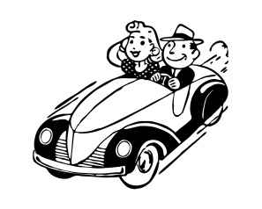 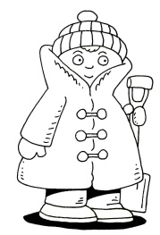

1. 2.

**3. Whose shoes are these? 4. Whose books are those?**

(She) (They)

 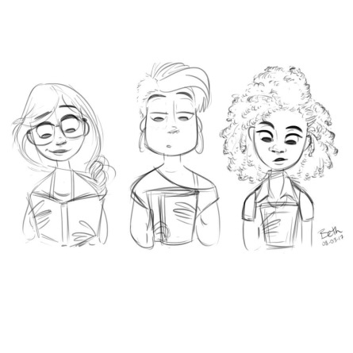

3. 4.

**5. Whose pencil is this? 6. Whose pet is this?**

(You) (I)

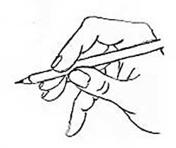 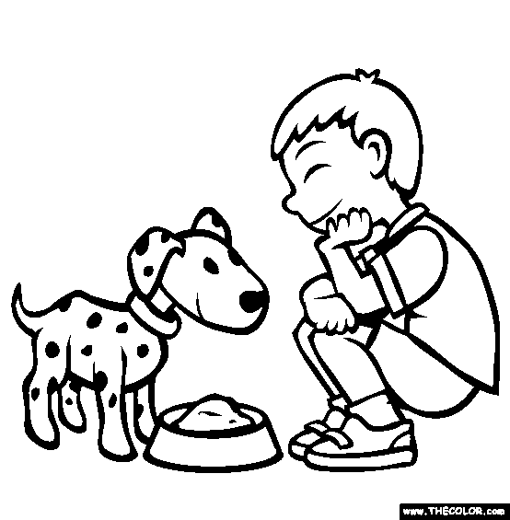

5. 6.