Listening

Listen and number.  / 8 marks

1

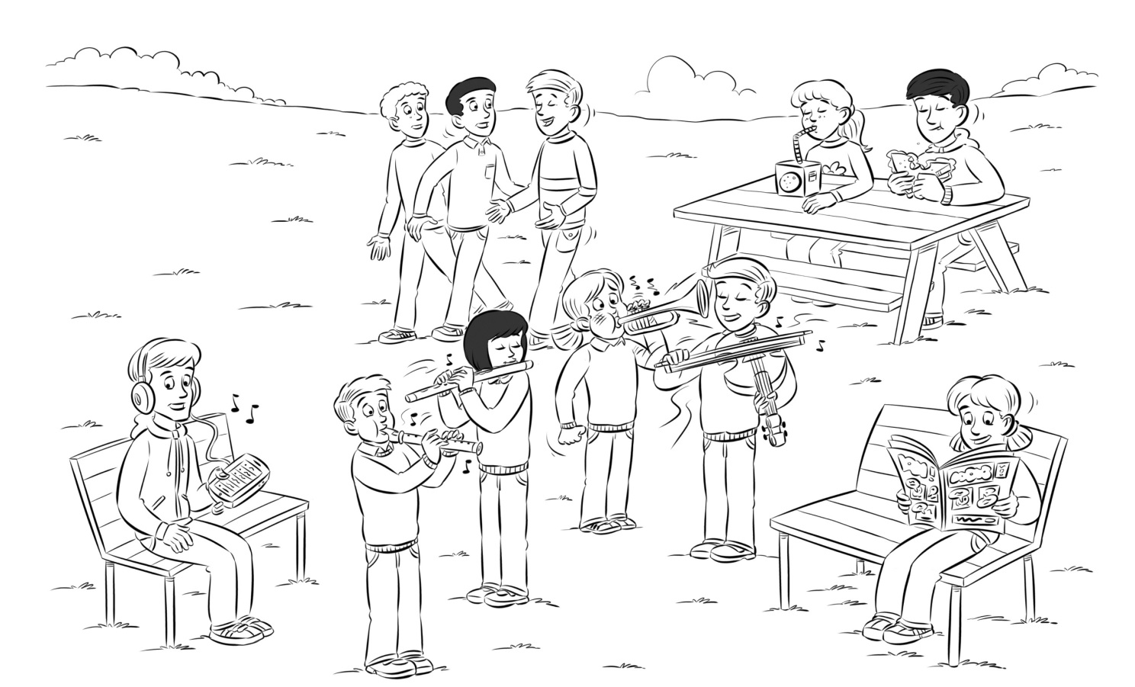

Reading

1

2

3

4

5

6

7

8

Read and write *True* or *False*. / 8 marks

2

|  |  |  |  |  |
| --- | --- | --- | --- | --- |
| RFTPS3TRDEVAL010a-p_word-copy_03 | This is my friend.  He can play the drums. |  | RFTPS3TRDEVAL010a-p_word-copy_05 | What’s Mum doing?  She’s talking to friends. |
| RFTPS3TRDEVAL010a-p_word-copy_07 | Anna’s in the café.  She’s having a snack. |  | RFTPS3TRDEVAL010a-p_word-copy_08 | She can’t play the  recorder. Please stop. |
| RFTPS3TRDEVAL010a-p_word-copy_09 | This music isn’t very nice!  Sam can’t play the violin. |  | RFTPS3TRDEVAL010a-p_word-copy_10 | Tom’s in the café.  He’s playing games. |
| RFTPS3TRDEVAL010a-p_word-copy_11 | My brother’s in the living  room. He’s reading a comic. |  | RFTPS3TRDEVAL010a-p_word-copy_12 | This is my sister.  She’s playing chess. |

Writing

1

2

3

4

5

6

What’s he or she doing? Answer. / 6 marks

3

|  |  |  |  |  |  |  |  |  |  |  |
| --- | --- | --- | --- | --- | --- | --- | --- | --- | --- | --- |
| RFTPS3TRDEVAL010a-p_word-copy_15 |  | RFTPS3TRDEVAL010a-p_word-copy_17 |  | RFTPS3TRDEVAL010a-p_word-copy_18 |  | RFTPS3TRDEVAL010a-p_word-copy_19 |  | RFTPS3TRDEVAL010a-p_word-copy_20 |  | RFTPS3TRDEVAL010a-p_word-copy_21 |

1 He’s 4

2 5

3 6

Write the questions and answers. / 2 marks

4

|  |  |  |  |
| --- | --- | --- | --- |
| 1 | Can he  No | 2 | Can  Yes |

Total for test \_\_\_\_\_\_ / 25 marks